Name of the Student: G. Manasa | Academic Year: 2024
Registration Number: 241U1R3007 | Year & Term: 2nd Year & 1st Term
Study Level: UG | Class & Section: CSE (DS)
Course: Digital Electronics | Instructor: Nuzhath Farhana
Assessment: Lab Report – 4 | Date of Submission: 07/08/2025
Design and Implementation of BCD to Excess-3 Code Converter using Karnaugh Map Minimization and SimulIDE Software
Objective:
To design a BCD (Binary-Coded Decimal) to Excess-3 code converter circuit using Karnaugh Map simplification and simulate the logic circuit in SimulIDE.
Software Used:
- SimulIDE v1.x
- Platform: Windows
Logic:
Let the BCD input be A B C D (A is MSB, D is LSB).
We can generate Excess-3 code W X Y Z by adding binary 3 (0011) to the BCD input using a 4-bit binary adder.
Procedure:
- Launch SimulIDE software.
- From the component library, drag and drop:
  - 4 Toggle Switches for inputs A, B, C, D.
  - 4 LEDs for displaying output W, X, Y, Z.
  - Logic gates to build 4-bit binary adder.
- Connect the BCD inputs to the adder.
- Add binary 3 (0011) to the input using the adder.
- Connect the output of the adder to LEDs.
- Provide Vcc and Ground to the components.
- Run simulation and test for all BCD inputs (0000 to 1001).
Truth Table:
Decimal | BCD (A B C D) | Excess-3 (W X Y Z)
0 | 0000 | 0011
1 | 0001 | 0100
2 | 0010 | 0101
3 | 0011 | 0110
4 | 0100 | 0111
5 | 0101 | 1000
6 | 0110 | 1001
7 | 0111 | 1010
8 | 1000 | 1011
9 | 1001 | 1100
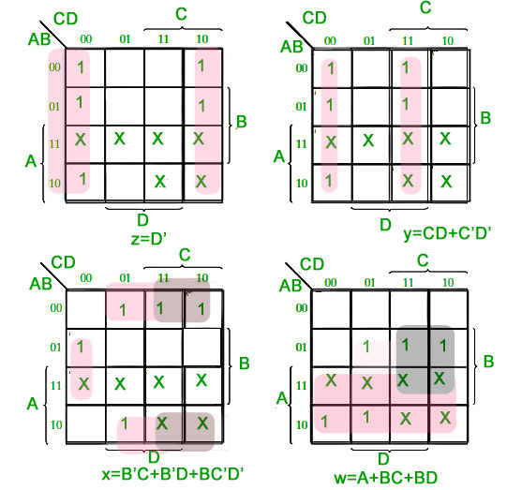
To find the corresponding digital circuit, we will use the K-Map technique for each of the Excess-3 code bits as output with all of the bits of the BCD number as input.
Corresponding minimized Boolean expressions for Excess-3 code bits:
w = A + BC + BD
x = B′C + B′D + BC′D′
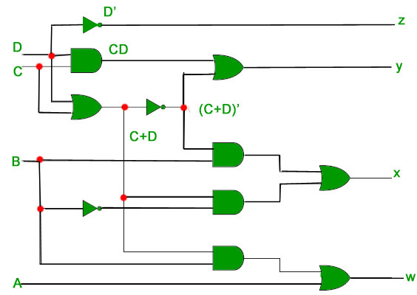
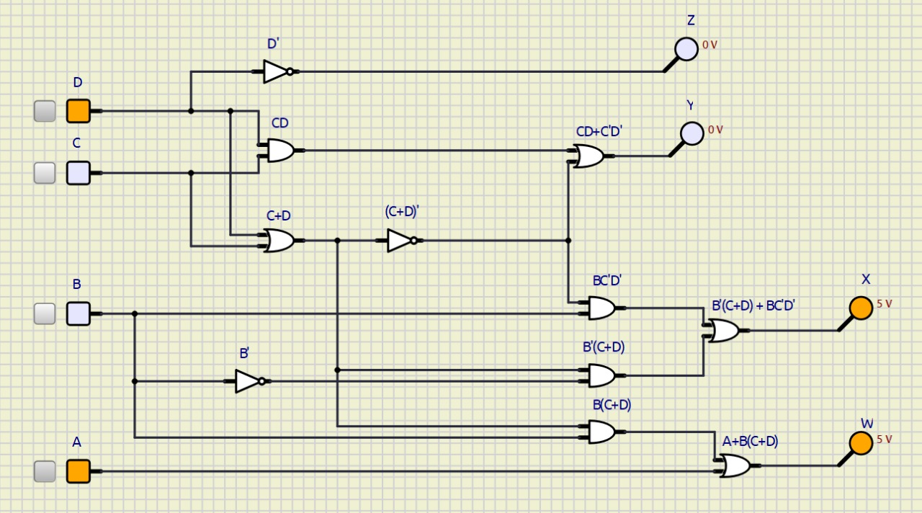
Result:
The BCD to Excess-3 code converter was successfully designed and simulated using SimulIDE. The output matched the expected Excess-3 code for all valid inputs.
Design and Implementation of Binary to Gray Code Converter using Karnaugh Map and SimulIDE
Objective:
To design a Binary to Gray Code Converter circuit using Karnaugh Map minimization, and simulate it using SimulIDE software.
Software Used:
- SimulIDE v1.x
- Platform: Windows
Let b0, b1, b2 and b3 be the bits representing the binary numbers, where b0 is the LSB and b3 is the MSB, and Let g0, g1, g2, and g3 be the bits representing the gray code of the binary numbers, where g0 is the LSB and g3 is the MSB.
The truth table for the conversion is
Binary (B3 B2 B1 B0) | Gray Code (G3 G2 G1 G0)
0000 | 0000
0001 | 0001
0010 | 0011
0011 | 0010
0100 | 0110
0101 | 0111
0110 | 0101
0111 | 0100
1000 | 1100
1001 | 1101
1010 | 1111
1011 | 1110
1100 | 1010
1101 | 1011
1110 | 1001
1111 | 1000
To find the corresponding digital circuit, we will use the K-Map technique for each of the gray code bits as output with all of the binary bits as input.
K-map for g0:
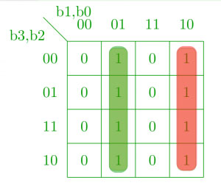
K-map for g1:
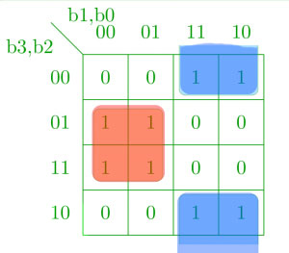
K-map for g2:
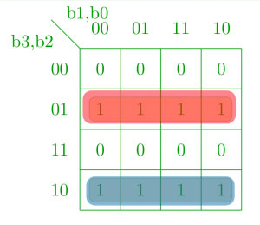
K-map for g3:
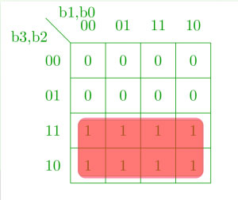
Corresponding Minimized Boolean Expressions and Digital Circuit for Gray Code Bits
g0 ​= b0​b1′ ​+ b1​b0′ ​= b0 ​⊕ b1​
g1 ​= b2​b1′ ​+ b1​b2′ ​= b1 ​⊕ b2​
g2 ​= b2​b3′ ​+ b3​b2′ ​= b2​ ⊕ b3​
g3 ​= b3
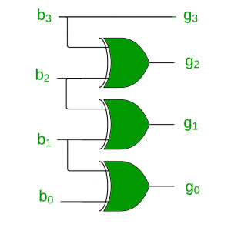
Procedure in SimulIDE:
- Open SimulIDE software.
- Drag and drop:
  - 4 Toggle Switches: for binary inputs A, B, C, D
  - 4 LEDs: for Gray code outputs W, X, Y, Z
  - Logic Gates: XOR gates (for X, Y, Z), direct wire for W
- Build the logic:
  - W = A
  - X = A XOR B
  - Y = B XOR C
  - Z = C XOR D
- Connect the inputs to gates, and outputs to LEDs.
- Power the circuit with Vcc and GND.
- Run the simulation and test for all 16 combinations.
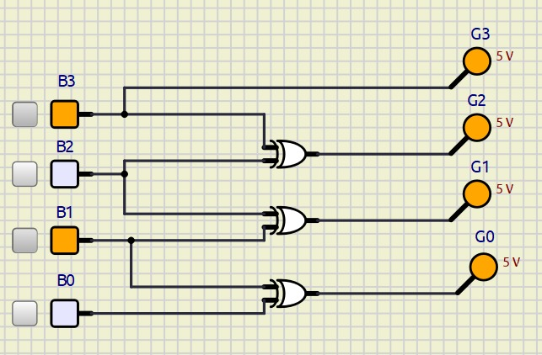
Result:
The Binary to Gray Code Converter was successfully designed using minimized Boolean expressions via K-Map and implemented in SimulIDE. The output Gray code matched the expected values for all binary inputs.
Design and Implementation of Gray Code to Binary Code Converter using Karnaugh Map and SimulIDE Software
Objective:
To design a Gray to Binary Code Converter using Karnaugh Map simplification and implement it using SimulIDE software.
Software Used:
- SimulIDE v1.x
- Platform: Windows
Converting gray code back to binary can be done in a similar manner. Let b0, b1, b2 and b3 be the bits representing the binary numbers, where b0 is the LSB and b3 is the MSB, and Let g0, g1, g2, and g3 be the bits representing the gray code of the binary numbers, where g0 is the LSB and g3 is the MSB.
Truth table:
Gray Code (G3 G2 G1 G0) | Binary (B3 B2 B1 B0)
0000 | 0000
0001 | 0001
0011 | 0010
0010 | 0011
0110 | 0100
0111 | 0101
0101 | 0110
0100 | 0111
1100 | 1000
1101 | 1001
1111 | 1010
1110 | 1011
1010 | 1100
1011 | 1101
1001 | 1110
1000 | 1111
Using K-map to get back the binary bits from the gray code.
K-map for b0:
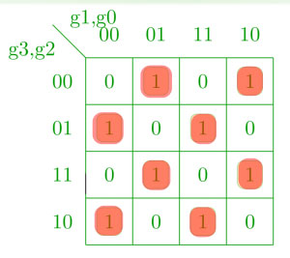
K-map for b1:
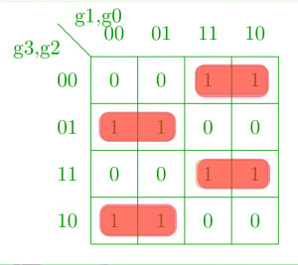
K-map for b2:
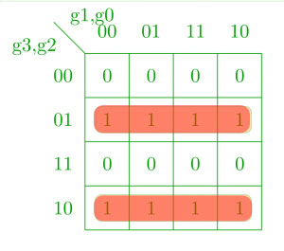
K-map for b3:
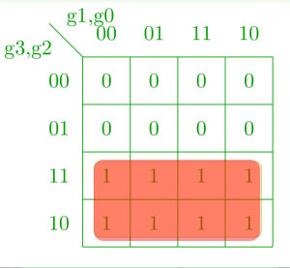
Corresponding Minimized Boolean Expressions
b3 = g3
b2 = g3 ⊕ g2
b1 = g2 ⊕ g1
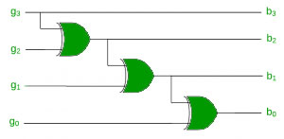
b0 = g1 ⊕ g0
Procedure in SimulIDE:
- Launch SimulIDE.
- Drag and place:
  - 4 Toggle switches for Gray inputs (W, X, Y, Z)
  - 4 LEDs for Binary outputs (A, B, C, D)
  - Logic gates: XOR gates
- Build logic circuits as per:
  - A = W
  - B = W ⊕ X
  - C = W ⊕ X ⊕ Y
  - D = W ⊕ X ⊕ Y ⊕ Z
- Connect Gray inputs to gates, and outputs to LEDs.
- Connect power supply and ground.
- Run simulation and verify outputs for all 16 Gray code values.

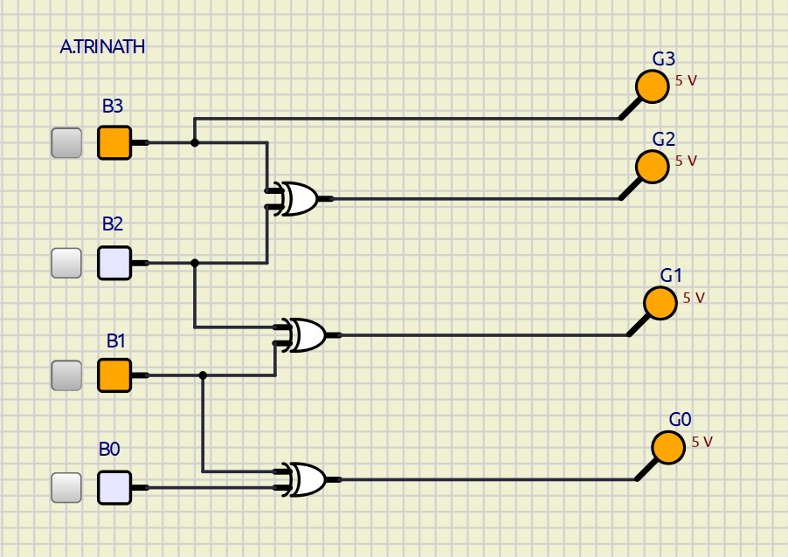
Result:
The Gray to Binary Code Converter was successfully designed using Karnaugh Map simplified Boolean expressions and implemented in SimulIDE. The circuit worked as expected for all valid Gray code inputs.

